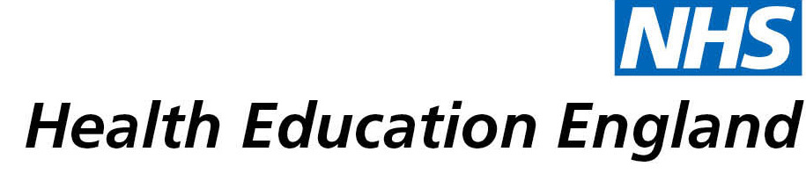

# Library and Knowledge Services case study

# *University Hospitals Birmingham LKS: Knowledge Café to reflect on learning and wellbeing from COVID 19 pandemic*

Date: 5th May 2021

## Reason for enquiry

*The wellbeing of UHB LKS staff has been affected by the Covid-19 pandemic. UHB LKS is a large team of 18 members of staff. During the initial stages of the pandemic, some staff worked from home, while others were redeployed to help out with the bereavement team and in ICU. All experienced a great period of change and uncertainty. This, as well as the pandemic more generally, had affected the mental wellbeing of the team.*

*The LKS team had returned to library work without having the time and space to process working through the pandemic and some of the changes this had brought with it. It was agreed during a team meeting that the library would run a virtual ‘Wellbeing Away Day’ for staff. A task and finish group was set up to organise the event and a Knowledge Café was selected as one of the main activities. A Knowledge Café was agreed on as it would allow the team to share experiences, insights and wellbeing tips, reconnect with different team members and surface opportunities for the library post lockdown.*

## What the knowledge and library specialist did

*Four members of the library team facilitated the Knowledge Café. This included creating the questions, managing the technological aspects (as the Knowledge Café was run through Microsoft Teams), facilitating group discussion and capturing knowledge gained.*

*The learning from the knowledge café and the feedback from the event was used to generate a report. Wellbeing posters and guidance for library staff were also created using tips gathered from the discussion.*

# Impact of input from the library and knowledge service

*The Knowledge Cafe helped LKS staff feel like their experiences were heard. The team was able to capture knowledge which both reflected on our work and experiences during the pandemic, and will inform service development in the future. The group was also able to share wellbeing tips which would then be used to create wellbeing posters and guidance for library staff.*

## Immediate Impact

*Over 80% of the team fed back that the event had a positive or very positive impact on their wellbeing. Having the opportunity to speak through experiences seemed to lift staff morale and made staff feel valued and listened to. The event was well received, one member of staff commented that it was ‘good to talk to people from other sites I hadn't talked to in a while and hear about people's different experiences’. Another noted that it was good to take ‘the chance to talk to all teams on a human level regarding our experiences, we should have done it sooner and need to do it again’*

## Probable future Impact

*The learning gathered from the Knowledge Café will be used to help shape service delivery post-lockdown. There was a discussion about what changes were made during the pandemic that we would like to keep and these will be used to inform the future direction of the service.*

*It is also hoped that, by focusing a Knowledge Café on wellbeing, this will be at the forefront of LKS staff minds. A mentally healthy workforce is more likely to create better quality of work and work more efficiently. Posters and wellbeing guides aimed at library staff will be created following this event with the aim of creating a holistically functioning team.*

*The Wellbeing Away Day and Knowledge Café were initially planned as a one-off event, however, it was so well received that it is likely that dedicating an afternoon to reflection and wellbeing will become an annual event in the UHB Library calendar. “I thought it was expertly organised and I actually got more out of this away day in comparison to any of our previous ones.”*

## Submission by:

*Emily Johnson, Outreach Librarian and Library Site Manager Good Hope Hospital*

## For further information on how you can get similar support contact your local NHS library and knowledge service.